Chapter 19
Globalization and International Investing

- False. Investments made in a local currency have the added risk associated with exchange rates. If an investment were made in dollars, the business risk of the firm would be the only risk born by the investor. If the investment is made in the local currency, the investor takes on both business risk and exchange rate risk.

- False. In almost all cases the statement is true, however, such diversification benefit is not assured. In those cases where there is no correlation coefficient between the international investment and the US portfolio, a diversification gain cannot be assured. In fact, should a high standard deviation security, with zero or one correlation with the US portfolio were added, the overall standard deviation of the portfolio would increase.

- False. Evidence shows that the minimum-variance portfolio is not the efficient choice. A capitalization-weighted portfolio of world indexes is likely to produce a better risk-return trade-off than the minimum-variance portfolio.

- True. By hedging, it is possibly to virtually eliminate exchange rate risk. The result is a set of returns based on the foreign stocks and not the currency fluctuations.

  - $10,000/2 = £5,000
£5,000/£40 = 125 shares

  - To fill in the table, we use the relation:
1 + r(US) = [(1 + r_{f} (UK)]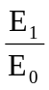
Price per | Pound-Denominated | Dollar-Denominated Return (%)  for Year-End Exchange Rate
Share (£) | Return (%) | $1.80/£ | $2.00/£ | $2.20/£
£35 | -12.5% | -21.25% | -12.5% | -3.75%
£40 | 0.0% | -10.00% | 0.0% | 10.00%
£45 | 12.5% | 1.25% | 12.5% | 23.75%

  - The dollar-denominated return equals the pound-denominated return when the exchange rate is unchanged over the year.

- The standard deviation of the pound-denominated return (using 3 degrees of freedom) is 10.21%. The dollar-denominated return has a standard deviation of 13.10% (using 9 degrees of freedom), greater than the pound-denominated standard deviation. This is due to the addition of exchange rate risk.

- First we calculate the dollar value of the 125 shares of stock in each scenario. Then we add the profits from the forward contract in each scenario.
Price per |  | Dollar Value of Stock  at Given Exchange Rate
Share (£) | Exchange Rate: | $1.80/£ | $2.00/£ | $2.20/£
£35 |  | 7,875 | 8,750 | 9,625
£40 |  | 9,000 | 10,000 | 11,000
£45 |  | 10,125 | 11,250 | 12,375
Profits on Forward Exchange:  [ = 5000(2.10 – E₁)] |  | 1,500 | 500 | -500

Price per |  | Total Dollar Proceeds  at Given Exchange Rate
Share (£) | Exchange Rate: | $1.80/£ | $2.00/£ | $2.20/£
£35 |  | 9,375 | 9,250 | 9,125
£40 |  | 10,500 | 10,500 | 10,500
£45 |  | 11,625 | 11,750 | 11,875
Finally, calculate the dollar-denominated rate of return, recalling that the initial investment was $10,000:
Price per |  | Rate of return (%)  at Given Exchange Rate
Share (£) | Exchange Rate: | $1.80/£ | $2.00/£ | $2.20/£
£35 |  | -6.25% | -7.50% | -8.75%
£40 |  | 5.00% | 5.00% | 5.00%
£45 |  | 16.25% | 17.50% | 18.75%

b. The standard deviation is now 10.24%. This is lower than the unhedged dollar-denominated standard deviation, and is only slightly higher than the standard deviation of the pound-denominated return.

- Currency Selection
EAFE: [0.30 × (–10%)] + (0.10 × 0%) + (0.60 × 10%) = 3.0%
Manager: [0.35 × (–10%)] + (0.15 × 0%) + (0.50 × 10%) = 1.5%
Loss of 1.5% relative to EAFE.

Country Selection
EAFE: (0.30 × 20%) + (0.10 × 15%) + (0.60 × 25%) = 22.50%
Manager: (0.35 × 20%) + (0.15 × 15%) + (0.50 × 25%) = 21.75%
Loss of 0.75% relative to EAFE.

Stock Selection
[(18% – 20%) × 0.35] + [(20% – 15%) × 0.15] + [(20% – 25%) × 0.50] = – 2.45%
Loss of 2.45% relative to EAFE.

- 1 + r(US) = [1 + r_{f} (UK)] × (F₀/E0) = 1.08 × (1.85/1.75) = 1.1417 ⇒ r(US) = 14.17%

- You can purchase now: $10,000/$1.75 = £5,714.29
This will grow with 8% interest to £6,171.43. Therefore, to lock in your return, you need to sell forward £6,171.43 at the forward exchange rate.

- The relationship between the spot and forward exchange rates indicates that the U.S. dollar is expected to appreciate against the Euro. Therefore, the interest rate in the U.S. is higher, in order to induce investors to invest in the U.S.

  - Using the relationship:
F₀ = E₀ × 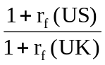=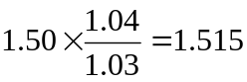

  - If the forward rate is 1.53 dollars per pound, then the forward rate is overpriced. To create an arbitrage profit, use the following strategy:
Action | Initial Cash Flow | Cash Flow at Time T
Enter a contract to sell £1.03 at a (futures price) of F₀ = $1.53 | 0.0 | 1.03 × (1.53 – E₁)
Borrow $1.50 in the U.S. | 1.50 | -1.50 × 1.04
Convert the borrowed dollars to pounds, and lend in the U.K. at a 3% interest rate | -1.50 | 1.03 × E₁
Total | 0 | 0.0159

  - Lend in the U.K.
  - Borrow in the U.S.
  - According to the interest rate parity relationship, the forward rate should be:
F₀ = E₀ × =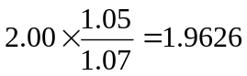
The strategy will involve:
Action | Initial Cash Flow | Cash Flow at Time T

Enter a contract to sell £1.07 at a (futures price) of F₀ = $1.97 | 0.0 | 1.07 × (1.97 – E₁)
Borrow $2.00 in the U.S. | 2.00 | -2.00 × 1.05
Convert the borrowed dollars to pounds, and lend in the U.K. at a 7% interest rate | -2.00 | 1.07 × E₁
Total | 0 | 0.0079

14. See results below

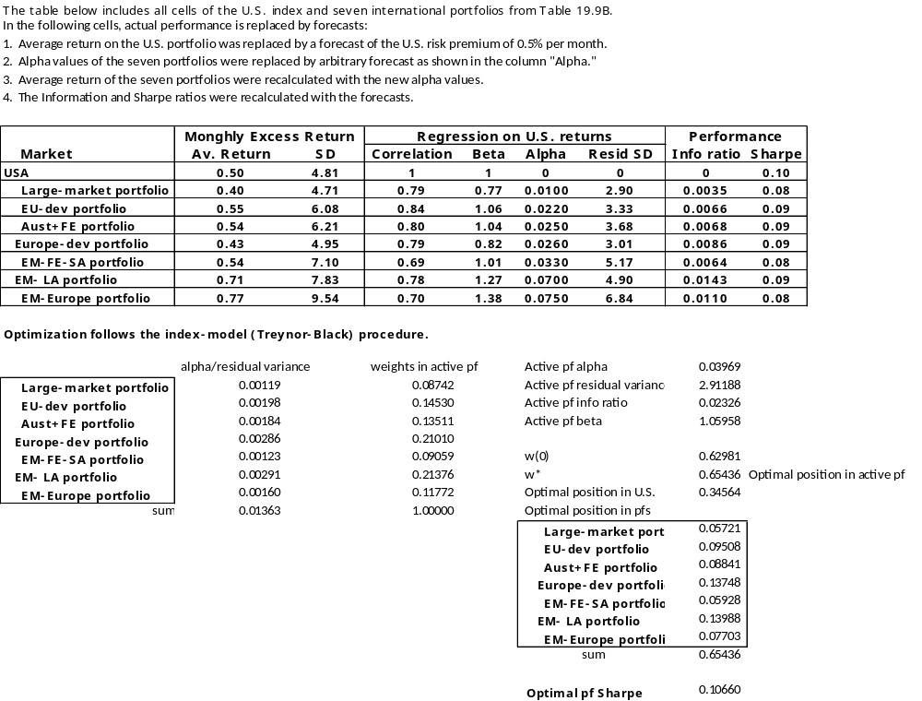
CFA 1
  - We exchange $1 million for foreign currency at the current exchange rate and sell forward the amount of foreign currency we will accumulate 90 days from now. For the yen investment, we initially receive:
1 million × 133.05 = ¥133.05 million
Invest for 90 days to accumulate:
¥133.05 × [1 + (0.076/4)] = ¥135.57795 million
(We divide the quoted 90-day rate by 4, since quoted money market interest rates typically are annualized using simple interest and assuming a 360-day year.)
If we sell this number of yen forward at the forward exchange rate of ¥133.47/dollar, we will end up with:
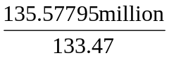= $1.015793 million
The 90-day dollar interest rate is 1.5793%.
Similarly, the dollar proceeds from the 90-day Swiss franc investment will be:
[$1 million × 1.526] × 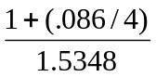= $1.015643 million
The 90-day dollar interest rate is 1.5643%, almost the same as that in the yen investment.

- The nearly identical results in either currency are expected and reflect the interest-rate parity relationship. This example thus asserts that the pricing relationships between interest rates and spot and forward exchange rates must make covered investments in any currency equally attractive.

- The dollar-hedged rate of return on default-free government securities in Japan is 1.5793% and in Switzerland is 1.5643%. Therefore, the 90-day interest rate available on U.S. government securities must be between 1.5643% and 1.5793%. This corresponds to an annual rate between 6.2572% and 6.3172%, which is less than the APR in Japan or Switzerland. (For consistency with our earlier calculations, we annualize the 90-day rate using the convention of the money market, assuming a 360-day year and simple interest). The lower interest rate in the U.S. makes sense, as the relationship between forward and spot exchange rates indicates that the U.S. dollar is expected to appreciate against both the Japanese yen and the Swiss franc.

CFA 2
- The primary rationale is the opportunity for diversification. Factors that contribute to low correlations of stock returns across national boundaries are:
i. imperfect correlation of business cycles
ii. imperfect correlation of interest rates
iii. imperfect correlation of inflation rates
iv. exchange rate volatility

- Obstacles to international investing are:
i. Availability of information, including insufficient data on which to base investment decisions. It is difficult to interpret and evaluate data that is different in form and/or content than the routinely available and widely understood U.S. data. Also, much foreign data is reported with a considerable lag.
ii. Liquidity, in terms of the ability to buy or sell, in size and in a timely manner, without affecting the market price. Most foreign exchanges offer (relative to U.S. norms) limited trading, and experience greater price volatility. Moreover, only a (relatively) small number of individual foreign stocks enjoy liquidity comparable to that in the U.S., although this situation is improving steadily.
iii. Transaction costs, particularly when viewed as a combination of commission plus spread plus market impact costs, are well above U.S. levels in most foreign markets. This, of course, adversely affects return realization.
iv. Political risk.
v. Foreign currency risk, although to a great extent, this can be hedged.

- The asset-class performance data for this particular period reveal that non-U.S. dollar bonds provided a small incremental return advantage over U.S. dollar bonds, but at a considerably higher level of risk. Each category of fixed income assets outperformed the S&P 500 Index measure of U.S. equity results with regard to both risk and return, which is certainly an unexpected outcome. Within the equity area, non-U.S. stocks, represented by the EAFE Index, outperformed U.S. stocks by a considerable margin with only slightly more risk. In contrast to U.S. equities, this asset category performed as it should relative to fixed income assets, providing more return for the higher risk involved.
Concerning the Account Performance Index, its position on the graph reveals an aggregate outcome that is superior to the sum of its component parts. To some extent, this is due to the beneficial effect on performance resulting from multi-market diversification and the differential covariances involved. In this case, the portfolio manager(s) (apparently) achieved an on-balance positive alpha, adding to total portfolio return by their actions. The addition of international (i.e., non-U.S.) securities to a portfolio that would otherwise have held only domestic (U.S.) securities clearly worked to the advantage of this fund over this time period.

CFA 3
The return on the Canadian bond is equal to the sum of:
coupon income +
gain or loss from the premium or discount in the forward rate relative to the spot exchange rate +
capital gain or loss on the bond.
Over the six-month period, the return is:
Coupon + forward premium/discount + capital gain =
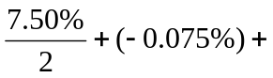Price change in % = 3.00% + % capital gain
The expected semiannual return on the U.S. bond is 3.25%. Since the U.S. bond is selling at par and its yield is expected to remain unchanged, there is no expected capital gain or loss on the U.S. bond. Therefore, in order to provide the same return, the Canadian bond must provide a capital gain of 0.25% (i.e., 1/4 point relative to par value of 100) over and above any expected capital gain on the U.S. bond.

CFA 4
- The following arguments could be made in favor of active management:
Economic diversity: the diversity of the Otunian economy across various sectors may offer the opportunity for the active investor to employ "top down" sector timing strategies.
High transaction costs: very high transaction costs may discourage trading activity by international investors and lead to inefficiencies that may be exploited successfully by active investors.
Good financial disclosure and detailed accounting standards: good financial disclosure and detailed accounting standards may provide the well-trained analyst an opportunity to perform fundamental research analysis in order to identify inefficiently priced securities.
Capital restrictions: restrictions on capital flows may discourage foreign investor participation and serve to segment the Otunian market, thus creating exploitable market inefficiencies for the active investor.
Developing economy and securities market: developing economies and markets are often characterized by inefficiently priced securities and by rapid economic change and growth. The active investor may exploit these characteristics.
Settlement problems: long delays in settling trades by non-residents may serve to discourage international investors, leading to inefficiently priced securities which may be exploited by active management.

The following arguments could be made in favor of indexing:
Economic diversity: economic diversity across a broad sector of industries implies that indexing may provide a diverse representative portfolio that is not subject to the risks associated with concentrated sectors.
High transaction costs: indexing would be favored by the implied lower levels of trading activity and costs.
Settlement problems: indexing would be favored by the implied lower levels of trading activity and settlement requirements.
Financial disclosure and accounting standards: wide public availability of reliable financial information presumably leads to greater market efficiency, reducing the value of both fundamental analysis and active management and favoring indexing.
Restrictions of capital flows: indexing would be favored by the implied lower levels of trading activity and thus smaller opportunity for regulatory interference.

- A recommendation for active management would focus on short-term inefficiencies in, and long term prospects for, the developing Otunian markets and economy, inefficiencies and prospects which would not generally be found in more developed markets.
A recommendation for indexing would focus on the factors of economic diversity, high transaction costs, settlement delays, capital flow restrictions, and lower management fees.

